Year 12 Essentials 2020
Test 2

Data Collection and Graphs


Name: _________________________________

Time for the task: 50 minutes

Resources allowed – Calculator, 1 A4 (one side) hand-written page of notes Total Marks: / 47

Task weighting: 8%

Full working out must be shown to get full marks.

Attempt all questions in the space provided.

Question 1 [4 marks; 1 each]

Classify each of the following data collections according to whether they are a sample or census.
- Favourite sports of secondary school students by surveying students in Year 10.

- Number of hours spent completing homework each week by you class by surveying each student in your class.

- Survey of all the customers leaving a sports shop between 10am and 11am to gauge customer satisfaction for that shop.

- The most popular colours for cars sold in the last month in Western Australia, taken from the registration board database of all cars registered in the last month.

Question 2 [9 marks; 3 each]

For each of the following investigations;
- State the population to be surveyed,
- Decide if a census or a sample should be used in collecting data.
- Give a reason for your answer.

- Students opinions of the school uniform at Baldivis Secondary College.

- Which venue should the year 12’s use for their school ball?

- The most popular supermarket in Western Australia.

Question 3 [2 marks; 1 each]

Give an example of how each of these sampling methods can be conducted.
- Random sampling:

- Systematic sampling:

Question 4 [3 marks]

A survey was conducted to find the satisfaction rating of the service provided at a local café. The day of the survey coincided with a hailstorm which affected the area. The survey conducted was self-selecting and five people participated. All the participants were 100% satisfied with the service provided. Explain why this data is misleading and unreliable, give two reasons. Provide an example of how data could be collected in a more reliable manner.

Question 5 [4 marks; 2 each]

Why are the following survey questions biased? Rewrite the question so that it is unbiased.
- Do you agree that the school uniform at Baldivis Secondary College needs to be changed?

- Rate how happy you are with the service received at the sports store:
□ Good □ Very Good □ Excellent

Question 6 [4 marks; 2 each]

In what way are the following samples biased? How could you get an unbiased sample?
- Asking people leaving a soccer match about their favourite sport?

- Asking random people at the shopping centre what they think of the uniform at Baldivis Secondary College

Question 7 [15 marks]

The table shows the linear relationship between the length of a mobile phone call and the cost of the call.
BEBO INTERNATIONAL MOBILE PHONE PLAN
Length of call (minutes) | 1 | 2 | 3
Cost (dollars) | 7.6 | 14.4 | 21.2

- Draw the graph of the mobile phone plan on the axis below. [2 marks]
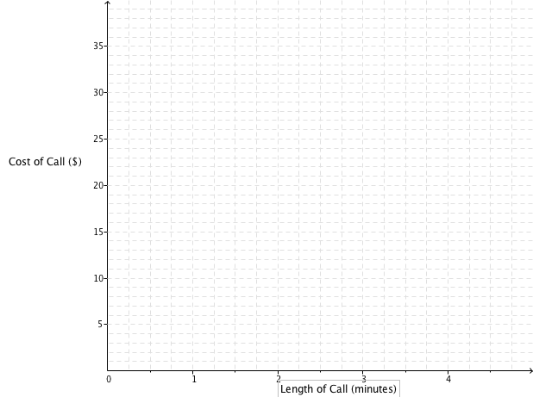

- What is the cost of a 4-minute phone call on this BEBO phone plan? [1 mark]

- What is the cost per minute for the BEBO phone calls? [2 marks]

- What is the rule to calculate the cost (c) of a phone call of (m) minutes on the BEBO phone plan?
[3 marks]

- GINTS international phone plan uses the formula c = 3.4m + 11. Draw this on the axis above.
[3 marks]

- Which mobile plan is better if I plan to make a phone call of 1.5 minutes? How much better would it be? [2 marks]

- What length of call are the two phone plans the same cost? What is the cost at this time? [2 marks]

Question 8 [6 marks; 3 each]

Paul owns a factory that makes sails. It costs $9000 per month to cover rent, electricity and wages in the factory. Each sail costs $250 to make and sells for $850.

- How many sails does Paul need to make and sell per month to break even?
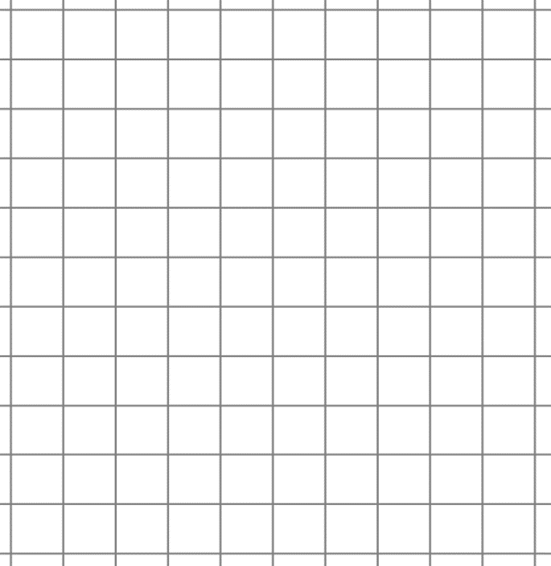

- What profit or loss will he make in a month if he makes and sells 20 sails?

End of Test

